Where Data is Stored

13.1 Introduction

In short, via a shell, the kernel accepts commands from the user and manages the processes that carry out those commands by giving them access to devices such as memory, disks, network interfaces, keyboards, mice, monitors and more.
A typical Linux system has thousands of files. The Filesystem Hierarchy Standard provides a guideline for distributions on how to organize these files. It is important to understand the role of the Linux kernel and how it both processes and provides information about the system under the /proc and /sys pseudo filesystems.

13.2 Processes
The kernel provides access to information about active processes through a pseudo filesystem that is visible under the /proc directory. Hardware devices are made available through special files under the /dev directory, while information about those devices can be found in another pseudo filesystem under the /sys directory.
Pseudo filesystems appear to be real files on disk but exist only in memory. Most pseudo file systems such as /proc are designed to appear to be a hierarchical tree off the root of the system of directories, files and subdirectories, but in reality only exist in the system's memory, and only appear to be resident on the storage device that the root file system is on.
The /proc directory not only contains information about running processes, as its name would suggest, but it also contains information about the system hardware and the current kernel configuration.
The /proc directory is read, and its information utilized by many different commands on the system, including but not limited to top, free, mount, umount and many many others. It is rarely necessary for a user to mine the /proc directory directly—it’s easier to use the commands that utilize its information.
There are also a number of regular files in the /proc directory that provide information about the running kernel:
File | Contents
/proc/cmdline | Information that was passed to the kernel when it was first started, such as command line parameters and special instructions
/proc/meminfo | Information about the use of memory by the kernel
/proc/modules | A list of modules currently loaded into the kernel to add extra functionality

13.2.1 Process Hierarchy
When the kernel finishes loading during the boot procedure, it starts the init process and assigns it a PID of 1. This process then starts other system processes, and each process is assigned a PID in sequential order.
As either of the init processes starts up other processes, they, in turn, may start up processes, which may start up other processes, on and on. When one process starts another process, the process that performs the starting is called the parent process and the process that is started is called the child process. When viewing processes, the parent PID is labeled PPID.
When the system has been running for a long time, it may eventually reach the maximum PID value, which can be viewed and configured through the /proc/sys/kernel/pid_max file. Once the largest PID has been used, the system "rolls over" and continues seamlessly by assigning PID values that are available at the bottom of the range.
Processes can be “mapped” into a family tree of parent and child couplings. If you want to view this tree, the command pstree displays it.

13.2.2 Viewing Process Snapshot
Another way of viewing processes is with the ps command. By default, the ps command only shows the current processes running in the current shell. Ironically, even though you are trying to obtain information about processes, the ps command includes itself in the output:
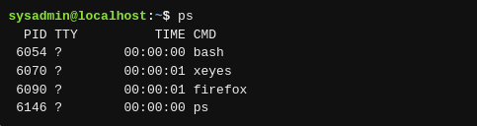

If you run ps with the option --forest, then, similar to the pstree command, it shows lines indicating the parent and child relationship:
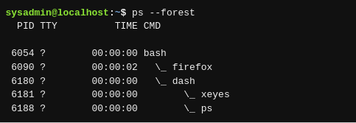

To be able to view all processes on the system execute either the ps aux command or the ps -ef command:

A common way to reduce the number of lines of output that the user might have to sort through is to use the grep command to filter the output display lines that match a keyword, such as a process name. For example, to only view information about the firefox process, execute a command like:


To use the traditional UNIX option to view the processes of a specific user, use the -u option:

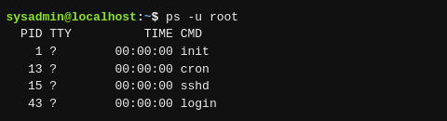

13.2.3 Viewing Processes in Real Time
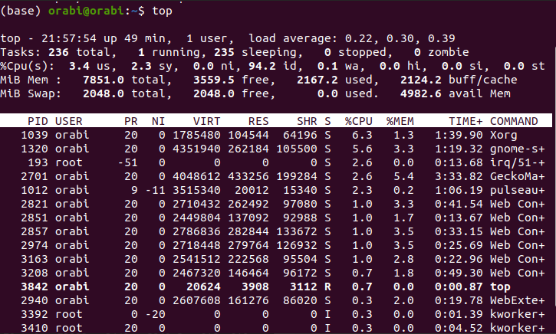
Whereas the ps command provides a snapshot of the processes running at the instant the command is executed, the top command has a dynamic, screen-based interface that regularly updates the output of running processes. The top command is executed as follows:

13.3 Memory
Memory on a modern Linux system is governed and managed by the kernel. The hardware memory on the system is shared by all the processes on the system, through a method called virtual addressing. The physical memory can be referenced by a number of processes, any of which may think they are able to address more memory than they actually can. Virtual addressing allows many processes to access the same memory without conflicts or crashes. It does this by allocating certain areas of a physical (or virtual) hard disk to be used in place of physical RAM. Memory is divided into blocks of equally sized units that can be addressed like any other resource on the system. Not only can the system access memory from local system addresses, but it can also access memory that is located elsewhere, such as on a different computer, a virtual device, or even on a volume that is physically located on another continent!
the -s option (how often to update) and specify that number of seconds. For example, executing the following free command would update the output every ten seconds:
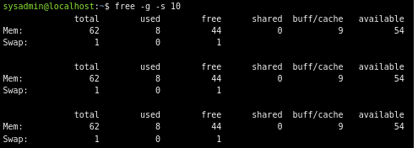

13.4 Log Files
As the kernel and various processes run on the system, they produce output that describes how they are running. Some of this output is displayed as standard output and error in the terminal window where the process was executed, though some of this data is not sent to the screen. Instead, it is written to various files. This information is called log data or log messages.
Log files are useful for many reasons; they help troubleshoot problems and determine whether or not unauthorized access has been attempted.
he log files themselves are almost always placed into the /var/log directory structure. Although some of the file names may vary, here are some of the more common files to be found in this directory:
File | Contents
boot.log | Messages generated as services are started during the startup of the system.
cron | Messages generated by the crond daemon for jobs to be executed on a recurring basis.
dmesg | Messages generated by the kernel during system boot up.
maillog | Messages produced by the mail daemon for e-mail messages sent or received.
messages | Messages from the kernel and other processes that don't belong elsewhere. Sometimes named syslog instead of messages after the daemon that writes this file.
secure | Messages from processes that required authorization or authentication (such as the login process).
journal | Messages from the default configuration of the systemd-journald.service; can be configured in the /etc/journald.conf file amongst other places.
Xorg.0.log | Messages from the X Windows (GUI) server.

For the files that contain binary data, there are commands available that will read the files, interpret their contents and then output text. For example, the lastb and last commands can be used to view the /var/log/btmp and /var/log/wtmp files respectively.

13.5 Kernel Messages
The kernel doesn't have its own log file normally, one can be configured for it by modifying either the /etc/syslog.conf file or the /etc/rsyslog.conf file. In addition, the dmesg command can be used to view the kernel ring buffer, which holds a large number of messages that are generated by the kernel.‌
On an active system, or one experiencing many kernel errors, the capacity of this buffer may be exceeded, and some messages might be lost. The size of this buffer is set at the time the kernel is compiled, so it is not trivial to change.
Executing the dmesg command can produce up to 512 kilobytes of text, so filtering the command with a pipe to another command like less or grep is recommended. For example, if a user were troubleshooting problems with a USB device, then searching for the text USB with the grep command is helpful. The -i option is used to ignore case:
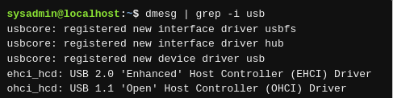

13.6 Filesystem Hierarchy Standard
A standard is a set of rules or guidelines that it is recommended to follow. However, these guidelines certainly can be broken, either by entire distributions or by administrators on individual machines.
The FHS standard categorizes each system directory in a couple of ways:
- A directory can be categorized as either shareable or not, referring to whether the directory can be shared on a network and used by multiple machines.
- The directory is put into a category of having either static files (file contents won't change) or variable files (file contents can change).
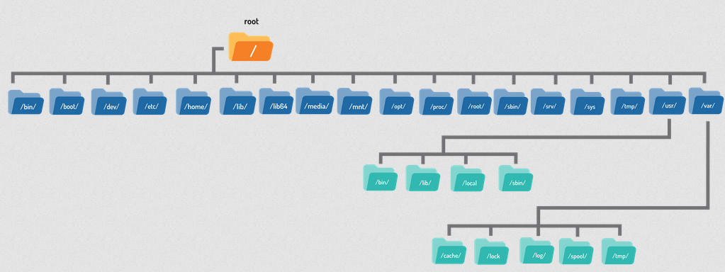
The FHS standard defines four hierarchies of directories used in organizing the files of the filesystem. The top-level or root hierarchy follows:
Directory | Contents
/ | The base of the structure, or root of the filesystem, this directory unifies all directories regardless of whether they are local partitions, removable devices or network shares
/bin | Essential binaries like the ls, cp, and rm commands, and be a part of the root filesystem
/boot | Files necessary to boot the system, such as the Linux kernel and associated configuration files
/dev | Files that represent hardware devices and other special files, such as the /dev/null and /dev/zero files
/etc | Essential host configurations files such as the /etc/hosts or /etc/passwd files
/home | User home directories
/lib | Essential libraries to support the executable files in the /bin and /sbin directories
/lib64 | Essential libraries built for a specific architecture. For example, the /lib64 directory for 64-bit AMD/Intel x86 compatible processors
/media | Mount point for removable media mounted automatically
/mnt | Mount point for temporarily mounting filesystems manually
/opt | Optional third-party software installation location
/proc | Virtual filesystem for the kernel to report process information, as well as other information
/root | Home directory of the root user
/sbin | Essential system binaries primarily used by the root user
/sys | Virtual filesystem for information about hardware devices connected to the system
/srv | Location where site-specific services may be hosted
/tmp | Directory where all users are allowed to create temporary files and that is supposed to be cleared at boot time (but often is not)
/usr | Second hierarchy  Non-essential files for multi-user use
/usr/local | Third hierarchy  Files for software not originating from distribution
/var | Fourth hierarchy  Files that change over time
/var/cache | Files used for caching application data
/var/log | Most log files
/var/lock | Lock files for shared resources
/var/spool | Spool files for printing and mail
/var/tmp | Temporary files to be preserved between reboots

